Why are two downloads 13 hours apart 1 byte different, and the HALT occurs at a different part of install?? Norton Smart Firewall disabled as requested by Norton chat. Diableing Auto Protect makes no difference. However, with both disabled, a message in the lower right corner sometime appears saying: “Data Protctor blocked multiple…”

Looks like a Norton problem to me

Install with file Moneydance_windows_amd64, downloaded at 8/9/2020 8:51 am 134,684 KB
Halt location on 9 Aug am.
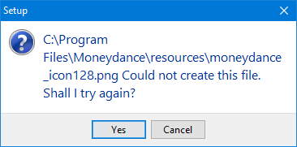

Install with file Moneydance_windows_amd64, downloaded at 8/9/2020 9:36 pm 134,685 KB
Halt location on 9 Aug pm, No reboot, and after reboot on 10 Aug
