hleofxquotes Program used with Moneydance
Cryptocurrencies and Market Indices V4
(Ref PDF “hleofxquotes Program used with Moneydance” for How To use Program & Security History Loader)
Always do a FILE- EXPORT BACKUP before following the procedures below.
Tested with Security History Loader Build 2038
OVERVIEW

Cryptocurrencies
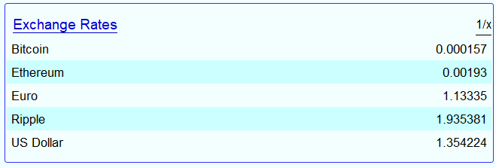
Moneydance is designed to handle normal currencies exchange rates but can also handle Cryptocurrencies. The hleofxquotes program can download Cryptocurrencies in a form that can be imported into Moneydance via Mike Brays Security History Loader. The process is outlined below, see here.
The 1/X inverts the listed values.
In the screen shot the setting is such that one unit of the Moneydances Base Currency = X units in the denomination displayed. The inverse would give one unit of the denomination displayed = X units in the Base Currency.
Moneydance does not indicate the selection 1/X is making.

Market Indices
Moneydance isn’t designed to track Market Indices, such as the Dow Jones Industrial Average,
FTSE 100 or Canadian S&P/TSX. However, it is possible to use the hleofxquotes Program to obtain data and Mike Brays Security History Loader to import that data into Moneydance and display this data thus. See here
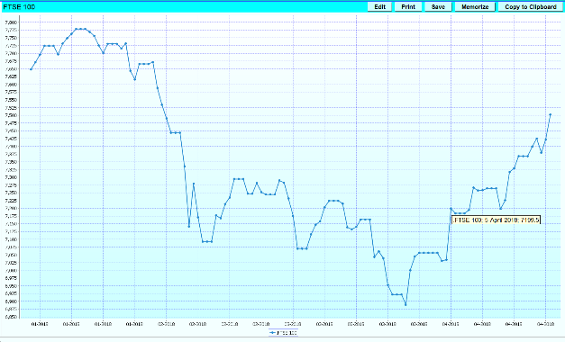
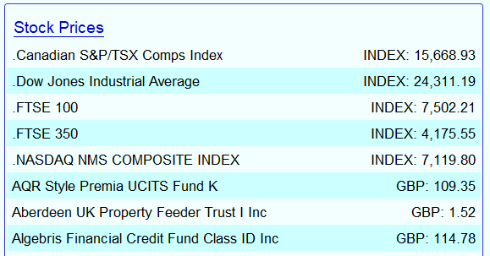

Contents
OVERVIEW 1
Cryptocurrencies 1
Market Indices 1
CRYPTOCURRENCIES 2
Setting up Cryptocurrencies in Moneydance as a currency. 2
Entering the cryptocurrency symbols into the Yahoo Symbols windows Tab. 2
Cryptocurrency exchange rates not supported by Yahoo 2
Import Cryptocurrency data using Security History Loader 2
Setting up Cryptocurrencies in Moneydance as an investment 3
Adding an Investment Account called Cryptocurrency. 3
Obtaining cryptocurrency quotes. 3
Cryptocurrency Table with hyperlinks 4
MARKET INDICES 4
Setting up Market Indices in Moneydance. 4
Adding a Currency Called INDEX. 4
Adding a Investment and Bank Account called Market Indices. 4
Creating a Market Index 5
Use the program to obtain index values 5
Import data using Security History Loader 5
Moneydance Summary Page 6
Market Index Graph 6
Market Index Symbol Table with hyperlinks. 7

CRYPTOCURRENCIES

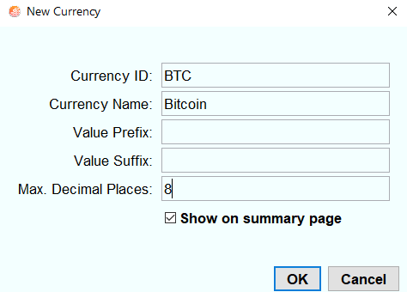
Setting up Cryptocurrencies in Moneydance as a currency.

In the example the cryptocurrency Bitcoin is added.
TOOLS – CURRENCIES then click “+” and fill in window thus.
Note the Symbol for the cryptocurrency must match the characters of the symbol given in the table here up to the “-“
Example for Ethereum use ETH and for DigitalCash use DASH
Click OK.

Entering the cryptocurrency symbols into the Yahoo Symbols windows Tab.
The format for the symbol is “cryptocurrency symbols – Currency” e.g. BTC-GBP see list of symbols here
The returned value gives the exchange rate of one Bitcoin = X GBP in the example one Bitcoin = 6316.08 GBP
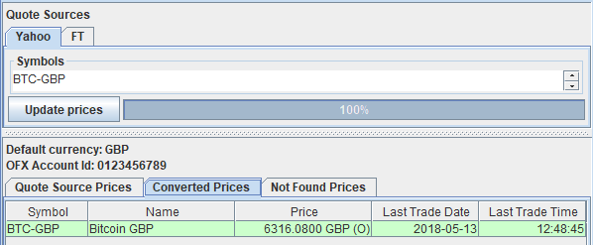
Enter a list of symbols one per line.

Cryptocurrency exchange rates not supported by Yahoo
In situations where Yahoo does not support an exchange rate to a specific currency then the hleofxquotes program can do the conversion. For, example Yahoo does not provide cryptocurrency exchange rates to the Danish Krone.
To overcome this simply enter the “cryptocurrency symbols – Currency” for a currency that is supported see here and add an exchange rate attribute on the next line.
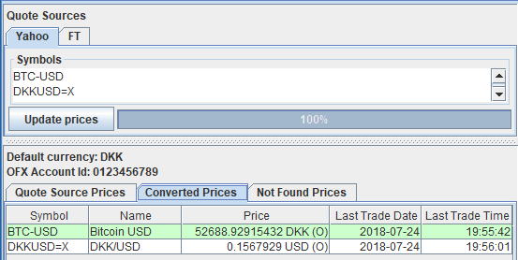
In the example of Bitcoin to return one Bitcoin = X DKK use the symbols
BTC-USD
DKKUSD=X

Run the program “Update Prices” and save a CSV file.

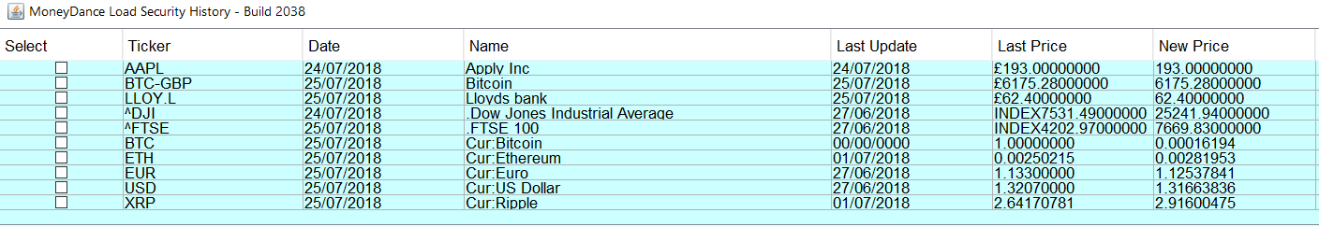
Import Cryptocurrency data using Security History Loader

Use the security History Loader in the normal way to load your Cryptocurrency exchange rates alongside, Securities,
Normal Exchange Rates and Market Indices.

See PDF “hleofxquotes Program used with Moneydance” for how to use the Security History Loader extension.

Setting up Cryptocurrencies in Moneydance as an investment
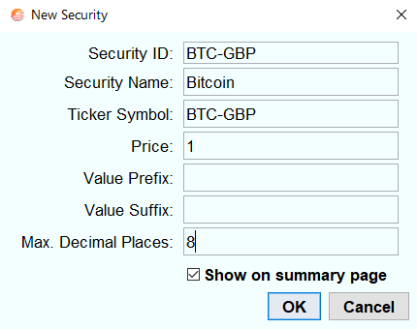
To track a cryptocurrency as an investment the cryptocurrency must be set up as a security.
In the example the Moneydance Base Currency is GBP.
Cryptocurrency Bitcoin is added as a security.
TOOLS – SECURITIES then click “+” and fill in window thus.
Note the Symbol for the security must match the characters of the symbol given in the cryptocurrency table here
Example for a Moneydance Base Currency of GBP for Ethereum use ETH-GBP and for DigitalCash with a Moneydance Base Currency of USD use DASH-USD
NOTE: When using Moneydance Base Currency not supported by Yahoo in terms of returning Cryptocurrency data see here. The security symbol used in Moneydance should be that used to obtain the cryptocurrency data. In the referenced example here BTC-USD would be used as the Bitcoin Security Symbol.
Click OK.

Adding an Investment Account called Cryptocurrency.
Create new investment account – “Cryptocurrency” in the normal way.
- Click on another account in the side bar then back to Cryptocurrency. Buy the security in the normal way by
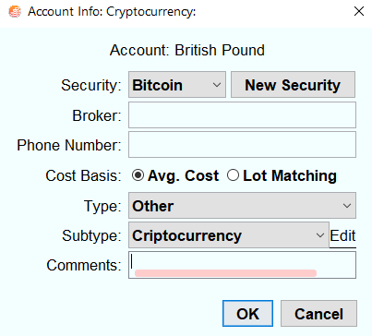
First Security click Yes, next time ACTIONS – ADD SECURITY.

- Fill in the window thus

- In this example 0.01 Shares at a Price of £6318 will be purchased equal to an
Amount of £63.18.
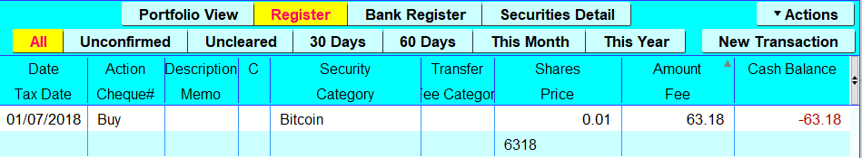
ACTION – NEW TRANSACTION and fill in transaction line thus.

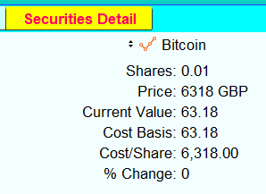
The Security Detail window will then look like this.

- Repeat steps 1 to 4 for each Cryptocurrency Security you wish to add.

Obtaining cryptocurrency quotes.
If you have already followed the section “Entering the cryptocurrency symbols into the Yahoo Symbols windows Tab” then there is no more to be done. If not follow that section here.
Import Cryptocurrency data using Security History Loader

Use the security History Loader in the normal way to load your Cryptocurrency exchange rates alongside, Securities, Normal Exchange Rates and Market Indices.

See PDF “hleofxquotes Program used with Moneydance” for how to use the Security History Loader extension.

Cryptocurrency Table with hyperlinks
Bitcoin | BTC-USD |  | BTC-GBP | BTC-CAD | BTC-EUR
Ethereum | ETH-USD |  | ETH-GBP | ETH-CAD | ETH-EUR
Ripple | XRP-USD |  | XRP-GBP | XRP-CAD | XRP-EUR
Bitcoin Cash BCC | BCH-USD |  | BCH-GBP | BCH-CAD | BCH-EUR
EOS | EOS-USD |  | EOS-GBP | EOS-CAD | EOS-EUR
Litecoin | LTC-USD |  | LTC-GBP | LTC-CAD | LTC-EUR
Tronix | TRX-USD |  | TRX-GBP | TRX-CAD | TRX-EUR
Cardano | ADA-USD |  | ADA-GBP | ADA-CAD | ADA-EUR
Stellar | XLM-USD |  | XLM-GBP | XLM-CAD | XLM-EUR
IOTA | IOT-USD |  | IOT-GBP | IOT-CAD | IOT-EUR
Vechain | VEN-USD |  | VEN-GBP | VEN-CAD | VEN-EUR
NEO | NEO-USD |  | NEO-GBP | NEO-CAD | NEO-EUR
Monero | XMR-USD |  | XMR-GBP | XMR-CAD | XMR-EUR
DigitalCash | DASH-USD |  | DASH-GBP | DASH-CAD | DASH-EUR
NEM | XEM-USD |  | XEM-GBP | XEM-CAD | XEM-EUR
Binance Coin | BNB-USD |  | BNB-GBP | BNB-CAD | BNB-EUR
Tether | USDT-USD |  | USDT-GBP | USDT-CAD | USDT-EUR
Ethereum Classic | ETC-USD |  | ETC-GBP | ETC-CAD | ETC-EUR
ByteCoin | BCN-USD |  | BCN-GBP | BCN-CAD | BCN-EUR
0x | ZRX-USD |  | ZRX-GBP | ZRX-CAD | ZRX-EUR
QTUM | QTUM-USD |  | QTUM-GBP | QTUM-CAD | QTUM-EUR
ICON Project | ICX-USD |  | ICX-GBP | ICX-CAD | ICX-EUR
Lisk | LSK-USD |  | LSK-GBP | LSK-CAD | LSK-EUR
Aeternity | AE-USD |  | AE-GBP | AE-CAD | AE-EUR
Bitcoin Gold | BTG-USD |  | BTG-GBP | BTG-CAD | BTG-EUR

MARKET INDICES

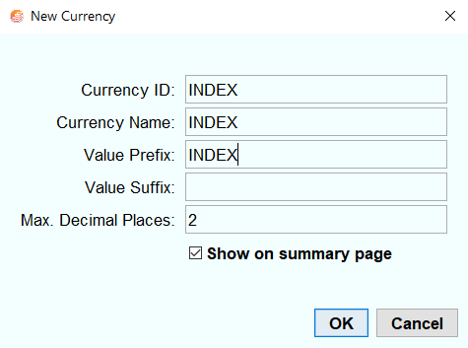
Setting up Market Indices in Moneydance.

Adding a Currency Called INDEX.
In the example screen shot above, word INDEX is used to prefix the index value.
To achieve this a currency called INDEX must be created.
TOOLS – CURRENCIES then click “+” and fill in window thus.
Click OK, close window.

Adding a Investment and Bank Account called Market Indices.
Create new investment account – “Market Indices” in the normal way.
ACCOUNT – NEW ACCOUNT – INVESTMENT – NEXT and enter the “Account Name” as “Market Indices”. Tick the box “Inactive”. Click OK.
Create new Bank account - “Market Indices” in the normal way.
ACCOUNT - NEW ACCOUNT – BANK – NEXT and enter the “Account Name” as “Market Indices”. Click OK.

Creating a Market Index.
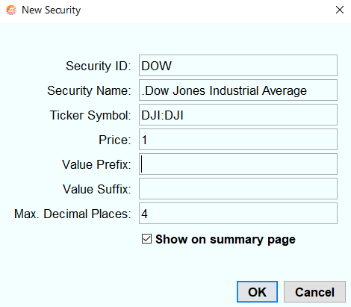
In this example the “Dow Jones Industrial Average” will be created.
Note the period “.”

”FT symbol. For Yahoo use “^DJI”

See Market Index Symbol Table here

- Create new security, -
“.Dow Jones Industrial Average” in the normal way.
TOOLS – SECURITES – “+”. Fill in the window thus.
Then OK. Close window.
- TOOLS – SECURITIES – “.Dow Jones Industrial Average”
– Change currency to “INDEX”, close windows.

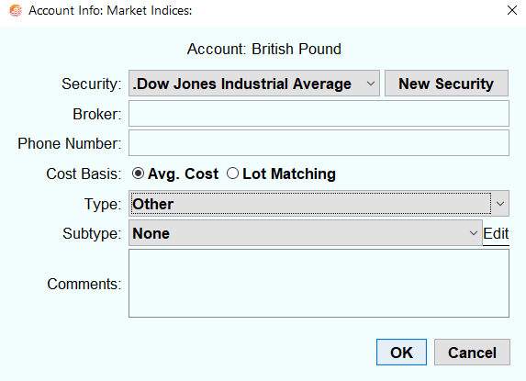
- Add security to investment account in the normal way.
Side bar highlight “ Market Indices. First Security click Yes, next time – ACTIONS - ADD SECURITY.
Fill in window thus.

Then OK.

- Click on another account in the sidebar then back to Market Indices. Buy the security in the normal way by
ACTIONS – NEW TRANSACTION and fill in trancaction line thus.
Enter Date Returned by Program for Index Value
- Repeat steps 1 to 5 for each Market Index you wish to add.
- Under TOOLS –ACCOUNTS –Market Indices (Type-Bank) –EDIT tick “Inactive”, then OK – DONE. If reqiured right click on BANKS: Market Indices in sidebar and select “Remove from side bar”. Note: If you want to add further Ixndices then you will need to make BANK: Market Indices active by unticking Inactive box under TOOLS – ACCOUNTS – Market Indices (Type-Bank) – EDIT then OK – DONE. Then follow steps 1-6 above.

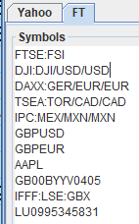
Use the program to obtain index values
Add Market index symbols, see here, to your list of security symbols in the “Symbols” window.
Note: The need to add an attribute after the index symbol to prevent currency conversion
for indices in a currency other than the default currency.
e.g. default currency GBP index currency USD attribute /USD/USD
Run the program “Update Prices” and save a CSV file.

There are a number of web sites that provide free CSV file downloads of historical index data for different Market indices for which you do not have to open an account. Once you have a history you can build on the data by using the hleofxquotes Program. Use your search engine to find one.

Import data using Security History Loader
Use the security History Loader in the normal way to load Market Indices alongside, Securities, Normal Exchange Rates and Cryptocurrency exchange rates.

See PDF “hleofxquotes Program used with Moneydance” for how to use the Security History Loader extension.
IMPORTANT: Dependant on the type of report and its settings the values of all the indices you have set up may be included, giving you an incorrect report. For relevant reports check under EDIT- SHOW: BY INDIVIDUAL that in the list of Investments “Market Indices” is deselected.

Moneydance Summary Page
Provided that under FILE – PREFERENCES – SUMMARY PAGE “Stock Prices” have been selected to be display then the Market Indices will appear at the top of the “Stock Price” list.

Market Index Graph
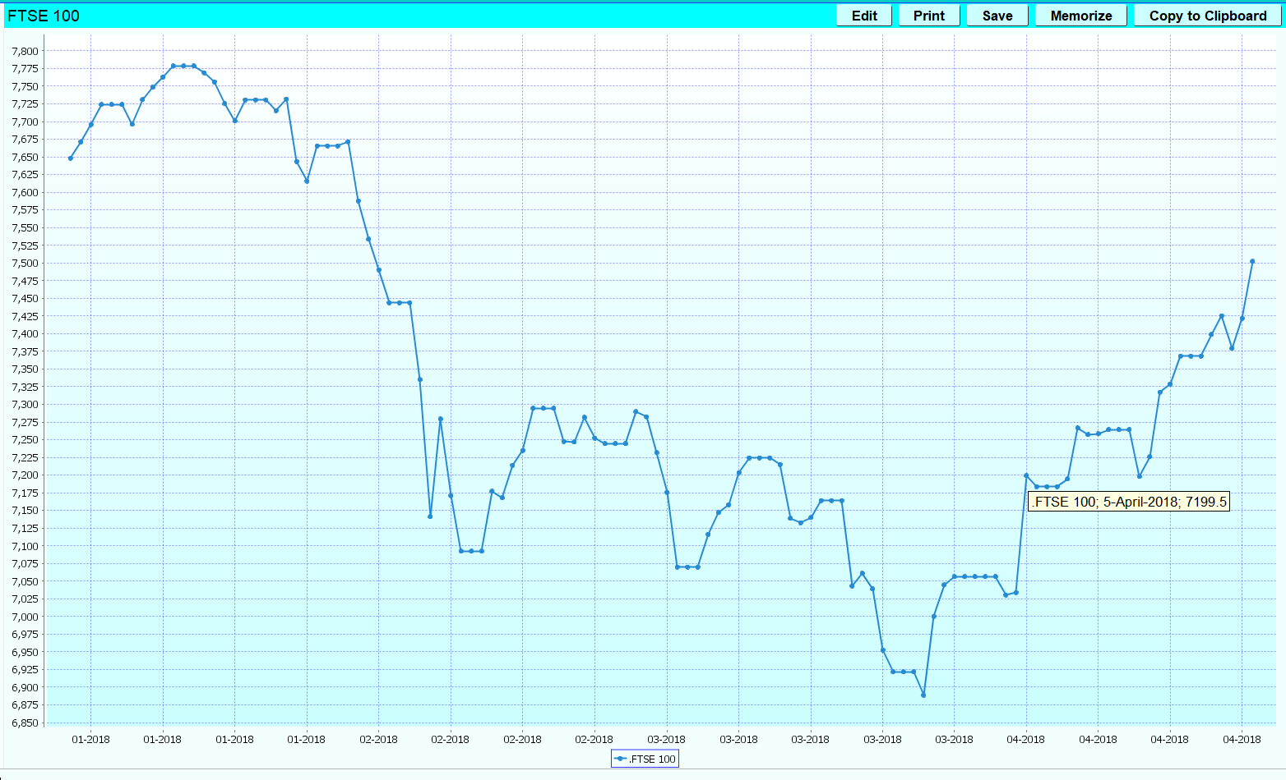
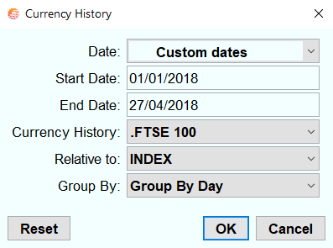
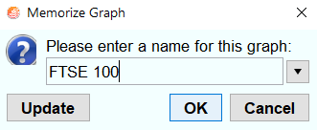
The Graphs “Currency History” can be used to show Market Index changes over time.

Click on EDIT and
Select Date Range
Currency History: Market Index
Related to: INDEX
Group By: Group By Day

Click on Memorize and enter Graph Name
e.g. FTSE 100

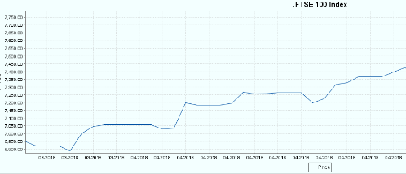
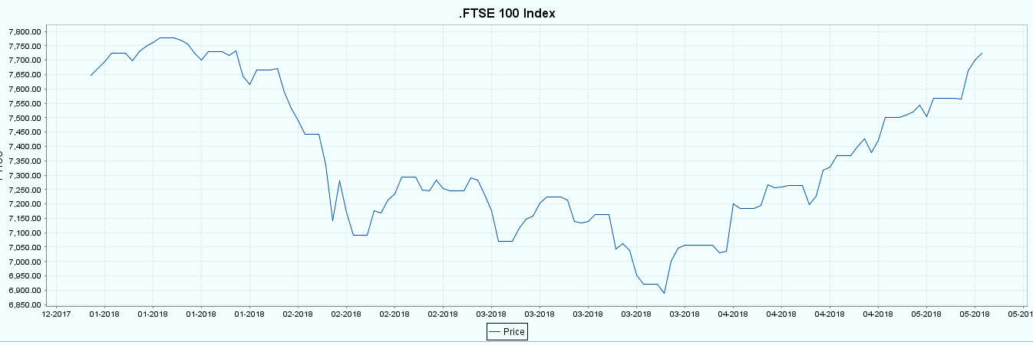
The Graph from Side Bar- Investment – Market Indices – Securities Details – FTSE 100 Index
Use Top Left to Bottom Right Sweep of Mouse to zoom in. Right Click to Zoom Out.

Market Index Symbol Table with hyperlinks.

FT SYMBOL | FT DESCRIPTION | YAHOO SYMBOL | YAHOO DESCRIPTION | CURRENCY
N100:PAR | Euronext 100 Idx | ^N100 | Euronext 100 | EUR
INX:IOM | S&P 500 Index | ^GSPC | S&P 500 | USD
SHI:SHH | Shanghai Se Composite Index | 000001.SS | Sse Composite Index | CNY
FTAL:FSI | Ftse All Share Index | ^FTAS | Uk Ftse All Share | GBP
FTSA:FSI | Ftse 350 Act Index | ^FTLC | Ftse 350 | GBP
CAC:PAR | Cac 40 Index | ^FCHI | Cac 40 | EUR
XJO:ASX | S&P Aust Index Asx 200 Index | ^AXJO | S&P/Asx 200 | AUD
PAX:PAR | Cac All Share Index | PAX.PA | Cac All Shares | EUR
COMP:NAS | Nasdaq Nms Composite Index | ^IXIC | Nasdaq Composite | USD
FTSE:FSI | Ftse 100 Index | ^FTSE | Ftse 100 | GBP
DAXX:GER | German Se Xetra Dax Index | ^GDAXI | Dax Performance-Index | EUR
TSEA:TOR | S&P/Tsx Comps Index | ^GSPTSE | S&P/TSX Composite Index | CAD
FTSM:FSI | Ftse 250 Mid Index | ^FTMC | Ftse 250 | GBP
n225:NIK | Nikkei 225 Tokyo | ^N225 | Nikkei 225 | JPY
DJI:DJI | Dow Jones Industrial Average | ^DJI | Dow Jones Industrial Average | USD
HSI:HKG | Hang Seng | ^HSI | Hang Seng Index | HKD
IPC:MEX | Se Ipc Index | ^MXX | Ipc Mexico | MXN

The above table represents a cross section of market indices across the world.
Reference the following two web sites to obtain further Market Indices.
Yahoo https://uk.finance.yahoo.com/world-indices FT https://markets.ft.com/data/world

Program set up for a mixture of Securities, Normal/Cryptocurrency Exchange Rates and Market Indices.
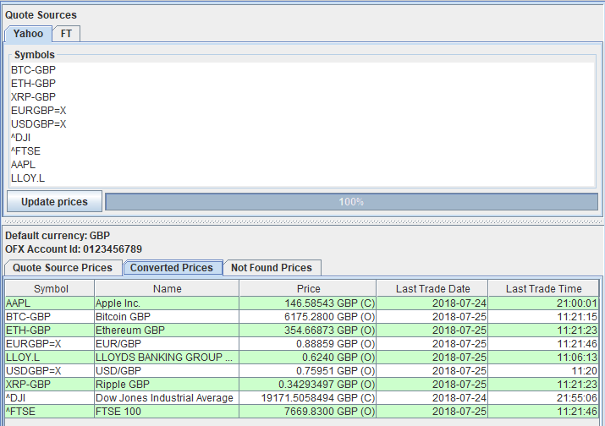

HAVE FUN

