Quote Loader

Mutual Funds not able to be retrieved
I have tried these funds on the three TSX (Canadian) Exchanges and each of the sources, to no avail.
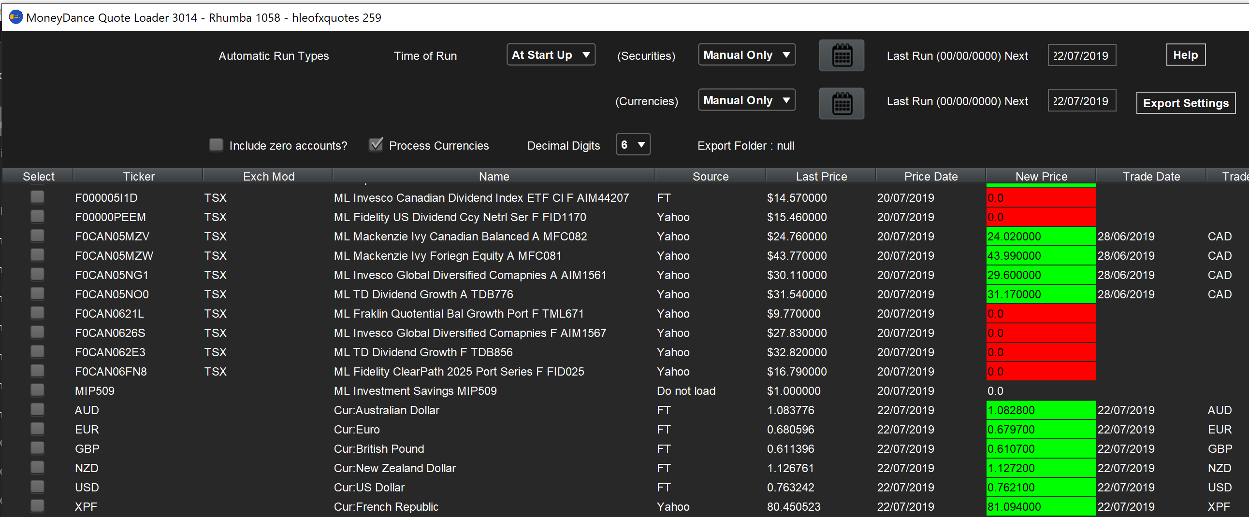

F000005I1D - Manulife Invesco Canadian Dividend Index ETF Cl F AIM44207
F00000PEEM - Manulife Fidelity US Dividend Ccy Netrl Ser F FID1170
F0CAN0621L - Manulife Fraklin Quotential Bal Growth Port F TML671
F0CAN0626S - Manulife Invesco Global Diversified Companies F AIM1567
F0CAN062E3 - Manulife TD Dividend Growth F TDB856
F0CAN06FN8 - Manulife Fidelity ClearPath 2025 Port Series F FID025

