**Quote Loader System by Mike Bray & hleofxquotes**

V6.2 **Use at your own risk**

# **OVERVIEW**

This system has been tested on the latest release of both Moneydance 2017 and 2019.

The Quote Loader system is a collaboration between the two software developers Mike Bray and Hleofxquotes.

The system provides an end to end solution, obtaining quotes from a choice of sources and entering them into the relevant History window, all from a single window within Moneydance. The system can obtain Security prices, Exchange Rates, Market indices, Cryptocurrency Rates and prices for Cryptocurrency Investments. For UK user’s prices are consistent, no switching between Pence and Pounds and back again. Returned prices in Pence will be automatically converted into Pounds before they are entered into the Security History window. Quotes and/or Securities in a foreign currency are converted into Moneydance’s Base Currency automatically. The selected source delivers the last traded price, not a price history, thus importantly it does not overwrite your existing history. It provides quotes for stocks and funds, from many stock exchanges US, Canada, UK, Europe and Australia to name but a few. The process of obtaining quotes from the selected source is fast and error free.

The system has the following advantages.

* You can see for each security, its Name and Ticker symbol.
* You can see for each security the Last Price and Price Date held in the History window.
* You can Select the Source to obtain quotes from.
* You can Get Prices for Exchange Rates and Securities or Exchange Rates only.
* You can determine if you want to get quotes for Securities you no longer hold.
* You can see each quote being returned with its New Price, Trade Date and Trade Currency.
* You can do a reality check before saving the data to Moneydance.
* You can see exactly what you are saving to Moneydance.
* You can add a New Price and Trade Date to any security that is not found.
* You can select the securities to be saved to Moneydance, all or selected prices.
* You can test a symbol before it is entered into Moneydance to check that a price can be returned.
* You can setup Auto Updating based on Daily, Weekly Quarterly, Monthly or Yearly intervals & time.

**When running the Quote Loader look under HELP – ONLINE HELP for further important information before obtaining prices. There is no guarantee that the Quote Loader system will continue to operate. Factors outside the developer’s control may change and the system will be unable to return quotes. Please do not use the data obtained from the Quote Loader for commercial gain. User’s should be aware of these warnings and only use the free Quote Loader system based on the acceptance of these conditions.**

**A YouTube Tutorial Video can be found** [**here**](https://youtu.be/_3tyr3Wz6vE)**.**

For how to set up Market Indices and/or cryptocurrencies in Moneydance see separate PDF.

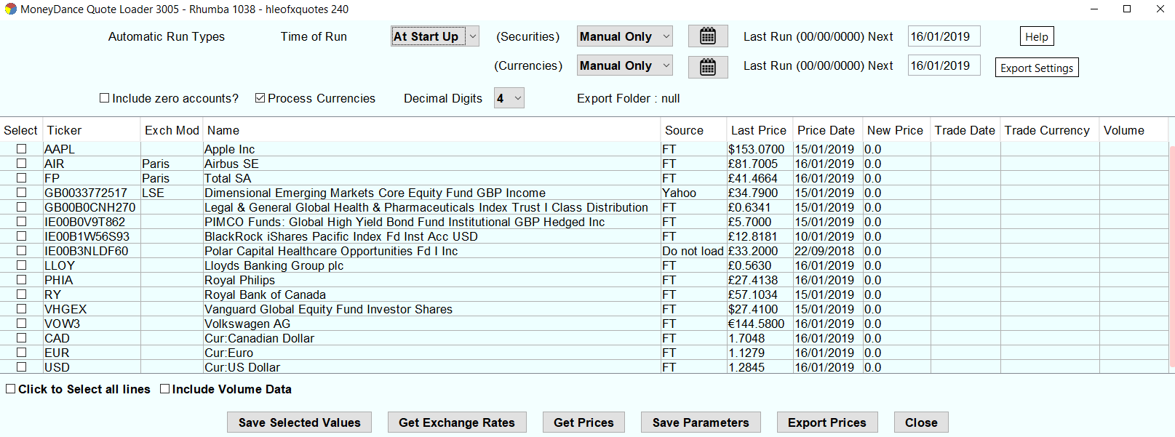**Example screen of the Quote Loader interface**

Table of Contents

**OVERVIEW** 1

**EXTENSION INSTALLATION** 3

**INITIAL SETUP** 4

**OBTAINING QUOTE** 5

Procedure if all Securities & Quotes are in Moneydance’s Base Currency 5

Export Data. 5

Procedure if one or more Securities or Quotes are not in Moneydance’s Base Currency. 6

**FINDING AND USING THE CORRECT SECURITY TICKER SYMBOL.** 7

**Testing Ticker Symbols using the Rhumba extension** 8

**RETURNED PRICE IS ZERO.** 8

**AUTOMATIC UPDATE** 8

**WARNING: NON-BASE CURRENCY SECURITIES WHEN USING 2017** 9

READ THE ENTIRE PDF

BEFORE ATTEMPTING TO USE THE QUOTE LOADER.

# **EXTENSION INSTALLATION**

Uninstall the Quotes and Exchange Rates Updater extension to Prevent Conflicts!!

Make a FILE – EXPORT BACKUP in case things do not turn out as expected.

The system consists of three elements.

* Quote Loader extension (securityquoteload.mxt), providing a user interface.
* The hleofxquotes program (hleOfxQuotes.jar), used to obtain quotes.
* The Rhumba extension (rhumba.mxt), a communications interface extension, to provide a communications link between the Quote Loader extension and the hleofxquotes program.

Once installed the hleofxquotes program and Rhumba extension, in use, are invisible to the user.

All parts of the system use the Java installation provided with Moneydance. A separate installation of Java is not required.

Download the zip file named QL-201X-release-yyyymmdd. There are two download sites.

For 2017 click [here](https://bitbucket.org/mikerb/moneydance-2015/downloads/) (“Mike Bray / Moneydance 2015 / Downloads” page. Don’t be put off by the 2015).

For 2019 click [here](https://bitbucket.org/mikerb/moneydance-2019/downloads/). The downloads are not interchangeable. The pages also contain other non-related Mike Bray extensions. Move the zip file to a new folder and unzip.

**New Users**. (Exiting users see section **Existing Users**)

Install the two extensions by dragging and dropping them into the Moneydance’s sidebar.

It’s safe to install both of these extensions, you can ignore the warning message.

The warning simply means that as third-party extensions they have not been reviewed and signed by Infinite Kind (Moneydance). The two developers, Mike Bray and hleofxquotes are responsible for several widely used programs. This new Quote Loader system has been tested by a number of experienced Moneydance users without any problems.

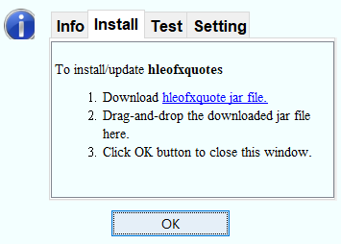Run the Rhumba extension from EXTENSIONS to give.

**Note: Do not tick box, at any time, unless asked to do so by a Quote Loader Developer.**

Select Install tab.

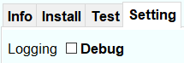

Drag and Drop the hleofxquotes program, hleofxquote.jar, into the window to install and click OK.

No need to run the hleofxquotes program, it runs when required invisible to the user. The same applies the Rhumba extension under EXTENSIONS.

When you run Quote Loader you should see the build numbers of the different elements displayed top of the Quote Loader window.

If the installation is incorrect, after up to a 10 second delay you will get a Warning message.

**Existing users**

Always update all three elements. Use the Grab and Drop process outlined above.

No need to uninstall the old builds first.

**Install securityquoteload.mxt first, followed by “hleOfxQuotes.jar” (when installing “hleOfxQuotes.jar” make sure rhumba Install tab selected), then “rhumba.mxt”.**

IMPORTANT: After first installation or after updating restart Moneydance.

# **INITIAL SETUP**

Make a FILE – EXPORT BACKUP in case things do not turn out as expected.

 Start the extension by selecting “Quote Loader” under EXTENSIONS to give.

5

1

2

7

3

4

6

NOTE: Mouse hover over a button or most tick boxes to display help tips.

1. If “Include zero accounts?” box is ticked then:
   1. If a security is assigned to an investment account but has a zero balance then it will appear whether or not it is listed in the Stock Prices section on the Summary Page.
   2. If a security is not assigned to an investment account then it will only appear if it is listed in the Stock Prices section on the Summary Page.
2. If you wish to update currency exchange rates tick “Process Currencies”. For a currency to be listed under “Ticker” symbols it must be selected in Moneydance to “Show on summary page” under TOOLS – CURRENCIES select currency - EDIT.
3. Most securities and currencies are quoted in no more than 4 decimal places but cryptocurrencies require up to 8. Use the “Decimal Digit” dropdown to select the number of decimal places returned.
4. In the “source” column change the default “Do not load” as required by selecting a quote source.

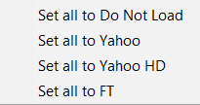Right click (ctrl-click for Mac) on Source heading to open a popup.

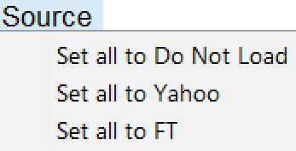

Select the most used Source.

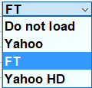Then to change an individual source. Click in a

source box and use a dropdown to make a selection.

If you not sure what source to select see here.

Note: Yahoo HD returns last available Closing Price, but cannot return Exchange Rates.

1. In the “Exch Mod” column, if required, change the default, Blank-Do not use an exchange, selection.

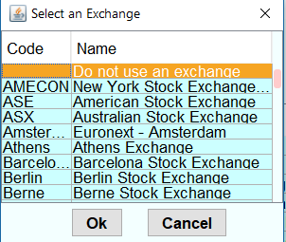

Click in an Exch Mod box to open a popup.

Select the Exchange were the Security is traded and click OK.

If you not sure what Exchange to select see here.

1. If you wish to update trade Volumes tick “Include Volume Data” box.
2. Click “Save Parameters”, OK. The next time you open the extension all the selection will be remembered.

# **OBTAINING QUOTE**

Make a FILE – EXPORT BACKUP in case things do not turn out as expected.

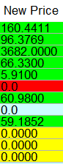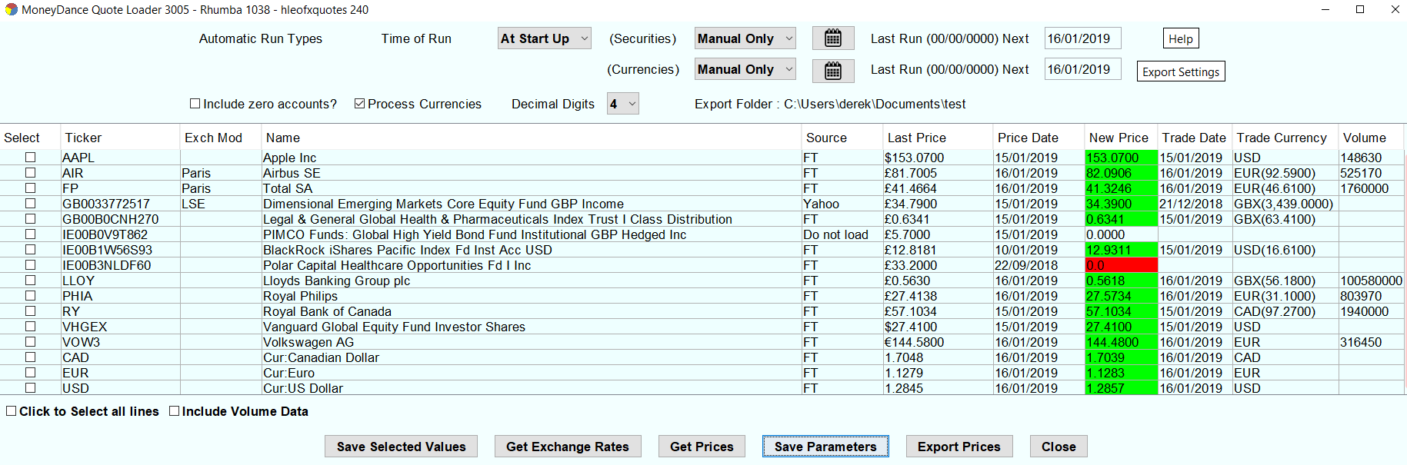 If not already running start the extension by selecting “Quote Loader” under EXTENSIONS to give.

4

1

1

1

5

1

2

1

Progress Bar may pause.

This is normal.

3

1

Do not tick until step 3.

The Moneydance Status Bar at the bottom of the main Moneydance window display the quote data as it is obtained



Status of obtaining quotes in indicated by colour.

* Yellow-Being obtained.
* Green-Obtained.
* Original colour-Do not load.
* Red-Not found.

## Procedure if all Securities & Quotes are in Moneydance’s Base Currency

1. Click “Get Prices” button and when progress bar reaches 100% click OK.
2. If security is returned in Red or original colour, with a zero price, see here
3. Tick the “Click to Select all lines” box or individual tick boxes to Select the values to be saved.
4. Click “Save selected values”, click OK button OR click “Close” to cancel Save.
5. Close the window.

Note: To obtain exchange rate only, tick Process Currencies, set Source for currencies and click

Get Exchange Rates.

## Export Data.

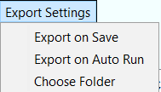If you so require you can export the data obtained to a CSV file. The menu allows you to

EXPORT ON SAVE, EXPORT ON AUTO RUN (tick as required) and

CHOOSE FOLDER for the exported CSV file.

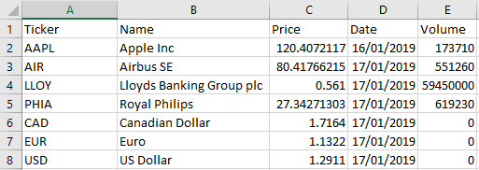Or you can use the button once you have

File Format

Note: The decimal separator used in the CSV file is always a “.” period.

chosen a folder and made a selection of the lines to be saved.

Note: Export Prices button does not save data to Moneydance.

File name format is priceexportyyyymmddhhmmss.csv

## Procedure if one or more Securities or Quotes are not in Moneydance’s Base Currency.

1. If Moneydance Base Currency if different from one or more securities/quote source currencies.

Example: Base Currency GBP. The security Volkswagen in TOOLS–SECURITIES–Volkswagen set to Euro.

Quote for Volkswagen obtained from the source are in Euro’s.



1. If one or more quotes are not in the currency of the security set in Moneydance.

Example The security BlackRock... In TOOLS–SECURITIES–BlackRock.. set to GBP. Quote for BlackRock.. obtained from the source are in USD. Base Currency is GBP.



Note: Currency difference £ symbol in Last Price column and Source value in USD in Trade Currency Column.

For the correct prices to be entered into Moneydance the process is in two stages.

* First stage.

Obtain and save the exchange rates.

In these example EUR and USD. In case A the exchange rate is used to convert the price in the History window to the Base Currency used in other areas of Moneydance. In case B the exchange rate is used in the second stage to convert the source quote price into the Base Currency before entering the value into the New Price column. In the BlackRock.. example the New Price will be converted from USD to GBP using the Last Price USD exchange rate.

* Second stage.

Obtain and save quotes.

Currency conversion. The process involves using an exchange rate to perform a currency conversion. For each security the system tries to use the exchange rate date that is the same as the security Trade Date. If this does not exist it looks into the past to find the first available exchange rate. This works well unless the exchange rate it finds is so out of date as to result in an inaccurate currency conversion. Regularly updating the exchange rate or at least the days prior to updating security price cut out errors.

Alternatively, on the completion of step a. you can do the following. Check the results to see if the Trade Date for any of the securities are older than the Trade Date for the related exchange rate. If yes, double click on the exchange rate Trade Date to enter the edit mode. Edit the Trade Date to equal the oldest Security Trade Date. Note: Clicking again in the edit mode will open a calendar. If you wish to remove the small conversion error that could exist you can edit the New Price exchange rate using one obtained on the web for that Trade Date.

The process steps are as follows: -

1. Click “Get Prices” button. When process is complete click OK.
2. Tick the boxes to select the exchange rates to be saved.
3. Click “Save selected values” button, click OK.
4. Click “Get Prices” button. When process is complete click OK.
5. If security is returned in Red or original colour, with a zero price, see here
6. Tick Select All box or individual tick boxes to select the values to be saved. It’s OK to enter exchange rates again.
7. Click “Save selected values” button.

# **FINDING AND USING THE CORRECT SECURITY TICKER SYMBOL.**

The first step is to determine which source you intend to use to obtain a quote for each security.

It’s possible one source will cover all your needs. Or it could be you need to use a mix of sources to find quotes for all your securities. If you find Yahoo is providing out of date prices try Yahoo HD (Closing Price), it may help.

Ticker symbols are unique within an exchange, but are not unique across all exchanges. For example, WBC is a valid Ticker symbol and both sources will return the same price, the price for WABCO Holdings. However, WBC is also the Ticker symbol for Westpac Banking Corp. and this company is traded on a number of stock exchanges, including Australia, New Zealand and various European Exchanges, each trading in a local currency. So, in such cases you must check that the Trade Currency and Price returned matches your expectations and if necessary, add an exchange code or select an exchange that results in the required outcome.

The Ticker symbol and stock exchange separator is “.” for Yahoo and “:” for FT. FT also supports some Yahoo “.” exchange codes.

Example. Apple Inc does not require an exchange code just use “APPL” for both sources. AirBus requires a “.PA” (AIR.PA) when the source is Yahoo, but a “:PAR” for FT (AIR:PAR). FT also supports (AIR.PA).

To help you determine the correct Ticker symbol and if required exchange code use

<https://markets.ft.com/data/equities> <https://uk.finance.yahoo.com/lookup>



In both cases enter the security name or the Ticker symbol itself, start without the Ticker symbol alone, to determine if it is recognised and if it requires an exchange code.

There are two ways the handle exchange codes.

1. When a source requires that the Ticker symbols has an exchange code enter then both under Moneydance TOOLS – SECURITIES. Example, if you have decided to use FT enter AIR:PAR or for Yahoo AIR.PA. Then set Exch Mod box to Blank - Do not use an exchange.
2. A more flexible approach is to only include the Ticker symbol under TOOLS – SECURITIES and use the Exch Mod column to add the exchange code automatically to the Ticker symbol. This way when you change sources the exchange code is changed automatically. There is no need to change the Ticker symbol under TOOLS – SECURITIES.

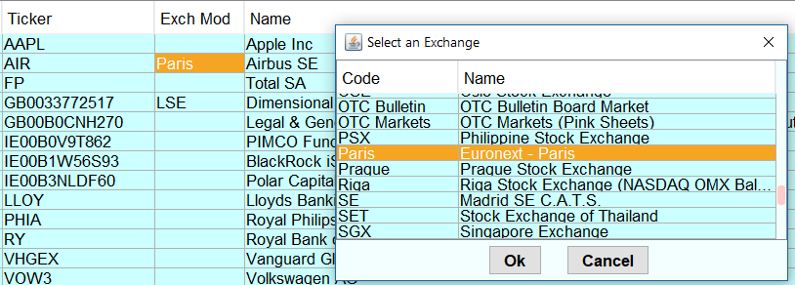

Clicking in an Exch Mod box open an exchange selection menu. Click OK once a selection is made.

Right click (ctrl-click for Mac) on an Exch Mod box to open a menu. One of the selections is “Set all exchanges to”. In the example this is Paris. Clicking on this sets all securities to have the Exch Mod of Paris. You can then set any individual securities Exch Mod box to the required exchange by clicking its box.

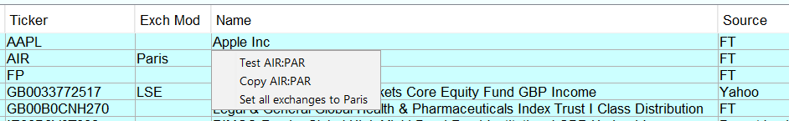To Test or Copy the Ticker symbol plus exchange code, if any, right click (ctrl-click for Mac) on an Exch Mod box and then click as required.

Be aware for a given security there are cases were the Ticker symbol changes, so to change sources you will still have to edit the Ticker symbol under TOOLS – SECURITIES. For securities that use the ISIN identifier e.g. GB0033772517 the two sources handle them differently. For FT select Blank - Do not use an exchange. For Yahoo select the appropriate exchange.

# **Testing Ticker Symbols using the Rhumba extension**

This feature allows the user to test a Ticker Symbol before it is entered under TOOLS – SECURITIES – “+”

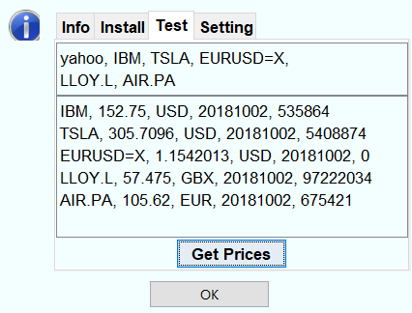

Run Rhumba under EXTENSIONS and click on TEST.

The top window shows a set of example Ticker Symbols which you can edited.

You can only test one source at at time. Sources Yahoo, YH, FT.

You can use more than one line. NOTE: Comma at end of line.

If the sourse requires a exchange symbol add at end. e.g. LLOY.L, AIR.PA

For currencies use the format, FT use GBPUSD, for Yahoo use GBPUSD=X

After click Get Prices. Ticker, Price, Currency, Date, Volume.

# **RETURNED** **PRICE IS ZERO.**

There could be two reasons why a quote is returned as a zero.

1. The Ticker symbol for the quote is incorrect for the quote source used. See here.
2. Neither quote source supports the quote or you have selected “Do not load quote”. In these cases, you will need to obtain a price from another source and enter it manually in to the associated “New Price” box. Double click on the box. Swipe over the existing value and enter the new value and press Enter. Then enter a Trade Date in the next box. Default date is todays date, edit as required. Note: Clicking again in the edit mode will open a calendar. Return to here.

# **AUTOMATIC UPDATE**

This feature will update your exchange rates and securities in the background without the need to open the Quote Loader extension. You can set the frequency of updates independently for exchange rates and Securities. Updates can be set to Daily, Weekly, Monthly, Quarterly or Yearly. You can use the associated calendar to set first day/date as appropriate. You can set the automatic update run at a specified time or just at start-up. A “Time of Run” Automatic Update will occur on the due date whilst Moneydance is open. On automatic update you will notice the update occurring in the background by quotes appearing in the status line at the bottom of the Moneydance window. If on opening Moneydance it is detected you have missed a due date/time the update will start. The Next Run date will increment after each update. The parameters used for the updates are those you saved when clicking the Save Parameter button. Before using this feature make sure you are happy with the quotes you are getting when using the Get Prices button, you want get to check the values that will be saved in automatic operation. If there is an error obtaining quote a message appears and the offending Price Date turns red with an asterisk. If you have securities or quotes that are not in the Base Currency then to prevent currency conversion errors it’s a good idea to set currency updates to daily. For background read the paraph Currency conversion here.

**RUN TYPE DROPDOWN**

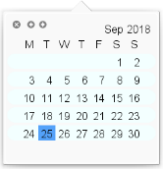**DAILY**



Click in box to open the calendar to set the start date.

Results in the message “Set the ‘Next Run Date’ you wish Automatic Running to start.

It will run daily from then on.

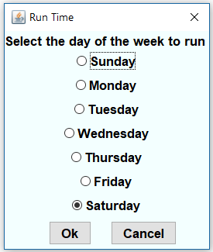**WEEKLY**

Results in the “Select the day of the week to run” window opening.

Make a selection and Click OK.

Click in the Next date box to open a calendar and select the date you wish Automatic Running to start. The selection should be the same day of the week.

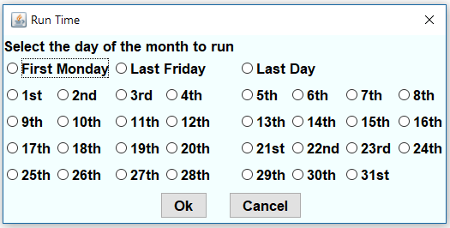**MONTHLY**



Results in the “Select the day of the month to run” window opening.

Make a selection and Click OK.

Click in the Next date box to open a calendar and select the date you wish Automatic Running to start.

The selection should be the same date.

If there are insufficient days in a month, e.g. you set the date to 30th and run it in February, the last day of the month will be used.

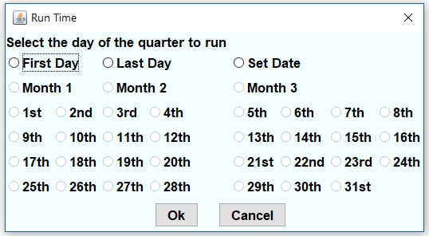**QUARTERLY**



Results in the “Select the day of the quarter to run” window opening.

Make a selection and Click OK.

Click in the Next date box to open a calendar and select the date you wish Automatic Running to start.

The selection should be the same date within a quarter.

If there are insufficient days in a month, e.g. you set the date to 30th and run it in February, the last day of the month will be used.



**YEARLY**

Click in box to open the calendar to set the start date.

Results in the message “Set the ‘Next Run Date’ to the date you wish Automatic Running to start.

It will run on the same day each year.

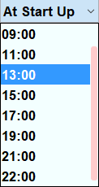**UPDATE TIME**

If Moneydance is opened and the due Time of Run, on the due date has passed, Automatic Update will start.

Click on “Time of Run” dropdown and select update time.

With Moneydance open an Automatic Update will occur at

the set time or At Start Up on the date programmed in the selections above.

# **WARNING: NON-BASE CURRENCY SECURITIES** **WHEN USING 2017**

The following has been fixed in Moneydance 2019.

For Non-Base Currency Securities do not update any Dated Currency Exchange Rates of the associated currency that coincide with the date of a Dated Security Price in the Security Price History window.

To do so will change the value of the Dated Security Price.” e.g. Base Currency GBP, Security Currency USD. In the Securities Price History window and the Currency History window there will be an entry with the same date. If you import a new exchange rate or manually edit the rate for that date, the security price for that date will change. This should not happen. The new exchange rate results in no change to the resulting base currency Security value for the same date. All reports associated with the security in the base currency for the same date remain the same. This is incorrect, they should change based on the updated exchange rate for that date. If you do change an exchange rate you will need to manually change the related security price for that date. This warning sound complex. The bottom line is unless you really have to don’t in any way update an existing dated exchange rate that coincides with a security in the same currency updated on the same date.

**HAVE FUN Derek Kent**