Trying to set up MD+ but the accounts show NO NAME
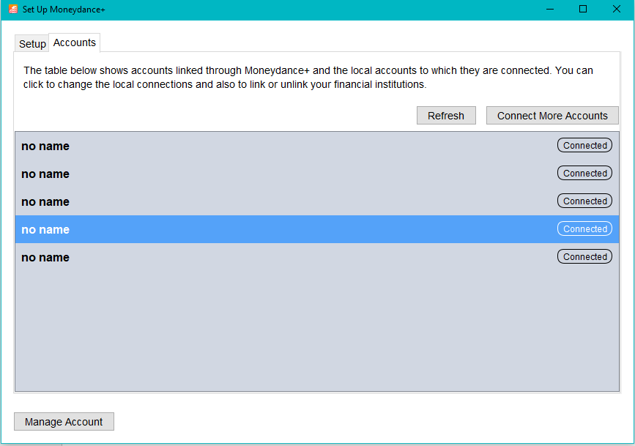

Hitting REFRESH gives the screen below
Hitting CONNECTED then REFRESH gives the same screen.
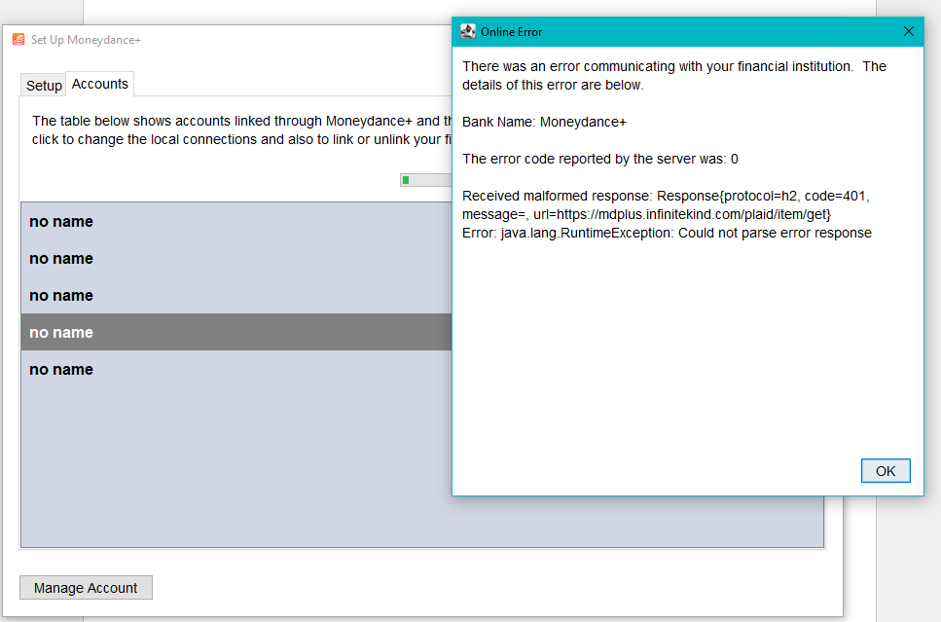

Hitting CONNECTED then DISCONNECT NO NAME gives
